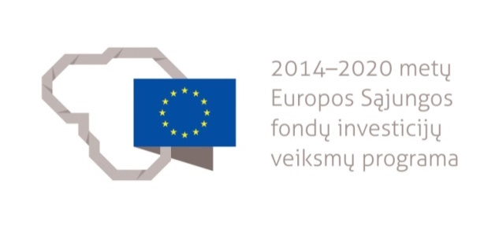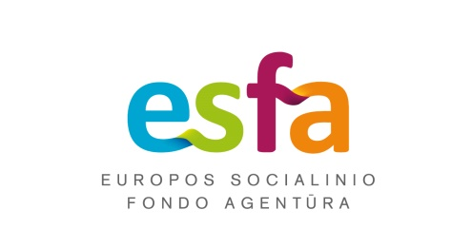

REGISTRATION FORM OF THE DIALECTOLOGICAL EXPEDITION ORGANISED BY LITHUANIAN UNIVERSITY OF EDUCATIONAL SCIENCES

The centre for Baltic studies the student comes from:

Data about the incoming student:

Surname:
Name:
Date of birth:
Citizenship:
Gender:
The year of studies of the student:
Proficiency of Lithuanian according to CEFR:
A1 A2
B1 B2
C1 C2
E-mail address:
Telephone:

Special requirements:

Head of the centre for Baltic studies submitting application
(Name, surname, signature)

The educational camp is organised in the framework of the project “Lithuanian Academic Scheme for International Cooperation in Baltic Studies” (No. 09.3.1-ESFA- V-709- 01-0002).
